

**وزارت تحصیلات عالی ج.ا.ا**

**ریاست موسسات تحصیلات عالی خصوصی**

**موسسه تحصیلات عالی میوند**

**پوهنځی کمپیوتر ساینس**



Transportation Management System (TMS)

**سیستم آنلان برای تکت ریزرویشن سفر**

By

Abdulfaheem Samadi

**2015-0737**

Bachelor of Computer Science

*Under the Supervision of*

*Mr. Hizbullah Watandost*

Assistant Professor

Maiwand Institute of Higher Education  
Taimani Project, Kabul Afghanistan

Spring - 2020



Maiwand Institute of Higher Education

Transportation Management System (TMS)

**سیستم آنلان برای تکت ریزرویشن سفر**

A Thesis Presented to

Maiwand Institute of Higher Education

In partial fulfillment

of the requirement for the degree of

Bachelor of Computer Science

By

Abdulfaheem Samadi

**2015-0737**

Spring - 2020

FINAL APPROVAL

The undersigned have examined the thesis entitled **‘Transportation Management System (TMS) – AsanSafar’**

presented by **ABDULFAHEEM SAMADI**, a candidate for the degree of **BCS (Bachelor of Computer Science)** and hereby certify that it is worthy of acceptance.

**_______________________ ___________________________**

Signature & Date Examiner

**_______________________ ___________________________**

Signature &Date Supervisor

________________________ ____________________________

Signature & Date Co-Supervisor (Where Required)

_________________________ Mr. M. Jamshid Mahboob

Signature & Date HoD

________________________ ____________________________

Signature & Date Dean of the Faculty

DECLARATION

I **Abdulfaheem Samadi** hereby declare that I have produced the work presented in this thesis, during the scheduled period of study. I also declare that I have not taken any material from any source except referred to wherever due that amount of plagiarism is within acceptable range. If a violation of Institute rules on research has occurred in this thesis, I shall be liable to punishable action under the plagiarism rules of the Institute.

_____________________  
 **Abdulfaheem Samadi  
 2015-0737**

CERTIFICATE

This is to certify that this thesis work entitled **AsanSafar** **Transportation Management System (TMS)** submitted by Fahim is a bachelor’s project work carried out under my supervision and guidance and fulfilling the nature and standard required for the partial fulfillment of the degree of Bachelor of Computer Science. The work embodied in this thesis has not been submitted elsewhere for a degree.

______________________________

Mr. Mohammad Jamshid Mahboob

# ACKNOWLEDGMENTS

Its customary and good manners to say thank you however, where do you draw the line? In some of the theses that I’ve read, and I write this after having read thousands, literally, the following and more have been acknowledged: God, one’s advisor, one’s better half, parents, children, friends, classmates, lab-mates, lab technicians, lab assistants, and so on.

The satisfaction that implies the successful completion of any work would be incomplete without the mention of people who made it possible.

I am indebted to my internal guide **Mr. Hizbullah Watandost** Assist. Professor, who has motivated and guided me throughout this thesis work. He has made the entire task simple with his valuable suggestions.

I wish to place on record my deepest appreciation to our beloved Dean Mr. Mujtaba Jawid Associate Professor, Computer Science Faculty, Maiwand Institute of Higher Education. I am thankful for his support and guidance throughout the completion of my thesis.

Finally, I would like to thank my parents, my friends and all those who have contributed directly or indirectly in my effort to complete this thesis.

**Abdulfaheem Samadi / 2015-0737**

# ABSTRACT

**AsanSafar Transport Management System (TMS)** project is developed for making present system of bus transportation paperless and more digitalized. This will make easy of business due to user friendly and easy to use system. Utilization of this system will increase the productivity. The main moto of this is to provide transport service to consigner and consignee. As due to computerization billing, summarized payment, creating report etc. will be permanently stored and will be easily available whenever need in future. Consequently, this will also decrease the work load in the office resulting in having more time investment in other productive tasks. Security and potential of the business also increases. Proper management and analysis can be done with the help of data stored and generated due to implementation of this digitalized system.

This Transport Management System (TMS) is the application developed to manage the transportation work easily keeping the transport agency up to date regarding the vehicles information. Transport agency has the work to transport goods from one city to another city. They have to keep track of each and every truck or others transport vehicles they have in their transportation company. They have to record each and every transport trip of the vehicles to manage the transportation business.

# TABLE OF CONTENTS

**Chapter Page**

DECLARATION ……………..i

CERTIFICATE ii

ACKNOWLEDGMENTS iii

ABSTRACT iv

TABLE OF CONTENTS v

LIST OF TABLES vii

LIST OF FIGURES viii

CHAPTER I 1

1.1. Introduction………………………………………………………………………...1

CHAPTER II 3

2.1. Literature Review…………………………………………………………………..3

2.2. Statement of Problem………………………………………………………………5

2.3. Objectives of Study………………………………………………………………...6

CHAPTER III……………………………………………………………………………...8

OBJECTIVE AND PRUPOSE………………………………………………………….8

3.1. Existing System. ………………………………………………………………...8

3.2. Purposed System. ……………………………………………………………......8

3.3. System Analysis. ………………………………………………………………...9

3.4. Objective of the system.. ……………………………………………………….10

CHAPTER IV……………………………………………………………………………..11

MOTHODOLOGY……………………….…………………………………………….11

4.1. Study on Electronic Ticketing in Public Transport.. ……………………………11

4.2. Online Transport Booking System………………………………………………11

4.3. Choice of Methodology………………………………………………………….12

CHAPTER V………………………………………………………………………………17

PROJECT DESIGN……………………………………………………………………..17

5.1. Data Flow Diagram (DFD) ……………………………………………………...17

5.2. Users use case diagrams………………………………………………………….19

5.3. Entity Relationship Diagram (ERD) …………………………………………….22

5.4 List of tables………………………………………………………………………23

5.5 Project main modules and features………………………………………………..27

5.6 Wireframes and pages……………………………………………………………..31

CHAPTER VI………………………………………………………………………………34

PROJECT IMPLEMENTAION & REQUIREMENTS…………………………………34

6.1. Software Requirements…………………………………………………………...34

6.2. Hardware Requirement…………………………………………………………...34

6.3. Advantages………………………………………………………………………..34

CONCLUSION……………………………………………………………………………..35

REFERENCES……………………………………………………………………………...36

1- Books & Research papers………………………………………………………....36

2- Websites…………………………………………………………………………...36

# LIST OF TABLES

**Table Page**

Table 1: Client Table 24

Table 2: Operator Table 24

Table 3: Admin Table…………………………………………………………………….24

Table 4: Client feedback table…………………………………………………………….25

Table 5: Contact us Table ………………………………………………………………...25

Table 6: Feedback collection Table……………………………………………………….25

Table 7: Logging Table…………………………………………………………………....26

Table 8: Membership Table………………………………………………………..……...26

Table 9: Agency Table…………………………………………………………………….26

Table 10: Vehicle Table……………………………………………………………………27

Table 11: Ticket Table …………………………………………………………………….27

Table 12: Website about Table …………………………………………………………….28

Table 13: Website name and log Table …………………………………………………….28

Table 14: Website slideshow Table………………………………………………………....29

# LIST OF FIGURES

**Figure Page**

Figure 1 SDLC life cycle 14

Figure 2 Agile model 17

Figure 3 Context View of Online Bus Ticket Reservation System 18

Figure 4 User view of Online Bus Ticket Reservation System 19

Figure 5 Admin view of Online Bus Ticket Reservation System ……………………….19

Figure 6 Admin use case diagram ……………………………………………………….20

Figure 7 Operator use case diagram ……………………………………………………..21

Figure 8 Client use case diagram ………………………………………………………...22

Figure 9 Entity Relationship Diagram (ERD) ……………………………………………23

Figure 10 AsanSafar modules and features ………………………………………………30

Figure 11 AsanSafar home page - 1 ………………………………………………………32

Figure 12 AsanSafar ticket search - 2 …………………………………………….………33

Figure 13 AsanSafar feedback and contact us -3 …………………………………………34

# CHAPTER I

## 1.1. Introduction

Transport management system (TMS) project is developed to automate transport operation like payment, booking order, delivery report, generating transactions receipt etc. in a transport office. Using this system user can computerize transport office work like billing, tracking payments, creating report etc. The main job of the transporter is to provide transport service to consigner and consignee.  
Transportation management system is a software application to maintain day to day transactions in transport office. Using this system user can manage transport work. He can select vehicle to transport the goods. He can also track the vehicle delivery of goods. Customer can also book good transport order online. User can also check his goods delivery status online.

This proposed system is designed to interconnect public transport vehicles and bus stations to "Central Room" to monitor the vehicles & traffic status. Based on the collected data and via analyzing road condition, estimated arrival times are computed and transmitted to all relevant stations. In this paper, we proposed a modified technique to predict vehicle arrival time. Achieving these main features will cause major improvements in public transport convenience and safety.

Our transport management system also allow user to keep records of their customer used. Transport management company keep records of every trip that has been taken by any transport vehicle, transport agency also records expenses incurred for a journey on a day. Our transport management system automates this process by calculating the total amount of a transport vehicle and also keep records of dues on the customer. Transport agency can also generate records by using the system to keep records or document the expenditure.

This transportation management system (TMS) helps the people to book a ticket anywhere and anytime. AsanSafar register the agencies and grant them membership. The contract form should be signed by the agency owner. The number of vehicles related to agency get registered in the system by the operator.

This system can be managed by the administrator and aerator. The administrator is just a super admin which can edit the client interface i.e. logo and website name, slideshow, about us details, feedback questions, contact details, manage reports and manage operators and other admins within the system. The operator is responsible for registering client, agency, agency’s vehicles, granting membership, managing tickets and clients will be the main responsibilities of operators.

# CHAPTER II

## 2.1. Literature Review

The prevalent view in various global circles is that man is presently living in an age growth of information gathering, processing and dissemination, popularly called the information age. For this reason, managers and other users of information especially in transport industries are demanding more kinds of information to support management and operations. They must therefore respond to the increasing requirement for information and data management.

Electronic tickets, or e-tickets, gives evidence that their holders have the permission to enter a place of entertainment, use a means of transportation, or have access to some Internet services. The design of this online system will be beneficial to the company because it has not existed before.

Therefore, AsanSafar transportation system is a viable investment owned me which my primary objective is to spread comfort and hospitality to passengers away from their home, to make profit, will definitely appreciate a system which can automate its manual operations in the area of bus ticket reservation in order to meet customers increasing demand during peak and off-peak seasons. The ultimate expectation is to inspire a feasibility study aimed at providing proper guidance and awareness to any future potential investors, particularly those in the bus industry, to consider utilizing the Imo transport, as a gateway to the fertile soil of unlimited opportunities in the Afghanistan.

Currently, staff at the bus ticket counter is using an internal system to sell tickets at the counter and customers who are unable to buy bus ticket online at this moment would have to go to the counter to a buy bus ticket. Sometimes, customers’ needs to queue up a long queue to buy bus ticket and ask for information and this brings a lot of inconveniences to customers. However, Online Bus Ticket Reservation System enables the customer to buy bus ticket, make payment, and ask for information online easily. Furthermore, staff can sell bus ticket using Bus Ticket Reservation System after checking the bus ticket availability for the customer and print the bus ticket to the customer.

Transport agency can generate bills using the system and check if any amount is remaining on any customer. User can also generate report to calculate the total expenditure on a vehicle on any transportation trip.

Intelligent Transportation Systems (ITS) domains include many areas as public transportation control framework, road traffic management and the application of traffic control. Vehicle monitoring and transportation management systems fall under the category of (ITS). Many previous studies and systems have been addressing intelligent transportation and vehicle monitoring systems (Han and Huh, 2011; Doğan et al., 2010; Hickman and Hanowski, 2011). Intelligent transportation systems enable various technologies to be applied in management of transportation and is defined as the use of information and communication technologies to collect, process, and transmit traffic data to transport users and operators (Qin et al., 2008). Vehicle monitoring systems, however, only take vehicles into account; for example, auto positioning systems can be applied to vehicle monitoring, vehicle control, and vehicle management. Addressing the problem of public transportation commuters in Egypt waiting for long time piling at the middle of the streets, struggling to catch a bus with all the suffering they meet, the delay they cause and the accompanying traffic digestion.

When travelling with buses, the passengers want to know the predicted bus arrival time at the bus stop. Long waiting time at bus stops may drive away the anxious travelers and make them reluctant to take buses. Accurate arrival time of next bus will allow travelers to take alternative transport choices instead, and thus mitigate their anxiety and improve their experience. Towards this aim, many commercial bus information providers offer the real-time bus arrival time to the public. Providing such services, however, usually requires the cooperation of the bus operating companies (e.g., installing special location tracking devices on the buses), and incurs substantial cost (F. Li Y. et al., 2011; Pengfei et al., 2012; Dihua et al., 2007). Many researches on implementing tracking systems based on android applications (Manav and Anupam, 2012; Ruchika and BVR, 2011), but most of them concentrated on tracking system not fully management transportation system and estimate arrival time predilection espials in countries complicated in traffic as Egypt. Our proposed system can be implemented based on website. The proposed transportation system is designed to interconnect public transport vehicles and bus stations to “Central Room” to monitor the vehicles & traffic status.

## 2.2. Statement of Problem

Currently, the type of system being used at the counter is an internal system which is manually used in selling the bus tickets. The problems facing the company are that customers have to go to the counter to buy bus ticket or ask for bus schedule, customers will also have to queue up for a long time in order to secure a bus ticket and will also need to pay cash when they buy the bus ticket.

## 2.3. Objectives of Study

The main objective of this application is to automate the complete operations of the goods transporter office. In current system all work is getting done manually. User have to manage many things so it is very difficult to manage this business doing work manually. Using this system user can automate many transport operations like billing, tracking payments, creating report etc. Using this system keeping records of transportation is easy. User can find any old records in few clicks. User can also generate old delivery reports and other report easily. They need maintain hundreds of thousands of records. Also searching should be very faster so they can find required details instantly.

The main purpose of this study is to automate the manual procedures of reserving a bus ticket for any journey made through Imo Transport Company (ITC). This system is said to be an automatic system and customers can select seats by themselves. Specifically, objectives of this project will consist of:

1. Providing a web-based bus ticket reservation function where a customer can buy bus ticket through the online system without a need to queue up at the counter to purchase a bus ticket.
2. Enabling customers to check the availability and types of busses online. Customer can check the time departure for every ITC bus through the system.
3. Easing bus ticket payment by obtaining a bank pin after payments is made to the various designated banks.
4. Ability of customers to cancel their reservation.
5. Admin user privileges in updating and canceling payment, route and vehicle records.

# CHAPTER III

## OBJECTIVE AND PRUPOSE

### 3.1. Existing System

Bus Transport Management System (BTMS) is designed to manage the booking and maintenance of growing bus transportation. Presently bus passengers frequently need to know about their ticket reservation status, ticket viability status on particular bus for particular destination, bus arrival and departure timing, halts and route of bus etc.

Customer information centers at the bus stations are unable to serve such quires at peak periods. Also, as for now there are no customer call centers facilities are available. Ticket booking in rural areas is much more difficult as people living there have to come all the way to the city where mostly Reservation Office and Bookings as well as Payments are done. Although there is computerized system, however does not have that great productivity and usefulness.

In existing system all work is done manually. In this system it is very difficult to find old records. Since all work is done manually, it takes time to give report to management regarding their query. To book an order user have to come transportation office. User can also not able to check his goods delivery status. All work is done on paper so it is error prone system. Sometime it is very difficult to manage all transport delivery. So, an automated system is needed to computerize all these activities.

### 3.2. Purposed System

There are number of advantages of Bus Transport Management System. This is comparatively to the present system faster and optimum requires less time for updating and fetching data. It working on it easier and the friendly user interface is cherry on the cake for the users. As required we can update and change the database if in future any new route or bus is implemented by the transportation management. Most importantly it saves time. It also costs less for maintaining as new technologies are used.

In Afghanistan still there is not any functional transportation system (TMS). Technology bring convenient in people live. So, there is must be a functional system in Afghanistan which should be used by people. So, I have developed this system which the people can create account, book a ticket, cancel a ticket. The system has intelligent search using which the user can search a ticket based on vehicle type i.e. bus, crolla, saraycha Tunness and etc., the source and destination place and departure time. The customer can share us their feedback and suggestions using our feedback interface. Our clients’ feedback is important for us, we can improve the system and add new features based on the clients’ feedback and suggestions.

Proposed system will automate all the work done manually in existing transport system. It will store all the records of goods delivery. Using this system user can online check rates of transportation and routes to the destination. Here user can check everything online and can book his order to transport his goods. User can also manage billing operation of transportation. Admin can also check which truck is available for transportation and how long it takes to reach the delivery point. This system provides the basic components of a shared information system to support the collaboration, rates, routes, roles, transaction sets, documents, and information exchanged to facilitate the booking, execution, and settlement of any type of transportation movement.

### 3.3. System Analysis

This Transport Management System is developed in such a way that user can access every functionality easily. This system is user friendly. User can easily create bills, book transport trip and create expense report. The old transport firm management system is very time consumption. User has to create manual work to manage the records. The maintenance of the old transport system is also very low. The old transport system is also less Secure and user has to do many extra-clerical works because this old transport system does not generate each and every record. To keep the records of the bills and expenditure Transport Company needs more man power. As user has to do many works manually then it is very difficult to stop irregularities in maintaining the record. And company need very intelligent and diligent employee to keep the records of transport related expenses. So, solving all these problems we have developed this project Transport management system. Our new system makes transport maintenance easy and requires less man power and less time for maintaining the records of the transportation firm. In our new system everything is computerized and transport management is totally transparent. As everything is automated in new system now user need minimal Clerical work involved to manage transport work. New transport management system is required less man power since all the paper work is automated in new system. new transport management system is user friendly with good look and feel and accurate.

### 3.4. Objective of the system

Objective of AsanSafar is to provide a solution for exiting challenges related to ticket reservation and ticket booking. We build the system with interactive user interface which can be used anyone within Afghanistan. Using this system, the Afghanistan people can search for a ticket, book a ticket and share us their feedbacks and suggestions. The ticket and vehicles can be managed by operator using the admin portal. The client interface can be changed by administrator and administrators can also manage logs and operators using the admin portal.

Bus Transport Management System makes transport maintenance easy and requires less man power and less time as well as cost for maintaining it. Various new concepts are implemented in this proposed system. HTML, XML, CSS for designing and front-end development of the system. Most popular technology nowadays in the fields of web development i.e. AJAX, JavaScript, PHP is also implemented having the major role in validation and for whole processing. With the help of documentation, it’s very much easy for the any third party to understand the system. As everything is automated now in new system now user need less Clerical work involvement to manage transport work.

# CHAPTER IV

## MOTHODOLOGY

### 4.1. Study on Electronic Ticketing in Public Transport

A consultant with European Metropolitan Transport Authority (EMTA), Mohamed Mezghani (2008) stated that EMTA has established a working group to work on the issue of electronic ticketing. This group is mandated to generate knowledge, exchange/compile information and learn from the experience of its members in the field of electronic ticketing. In his framework, EMTA has launched a study on electronic ticketing in public transport under the supervision of the working group and they designed certain concepts such as the public transport pricing, public transport ticketing and electronic ticketing in public transport.

On the contrary, his research which discussed certain concepts in relation to electronic ticketing in public transport was a one-directional article which didn’t relate the idea about customer reserving seats and for their journey at a date chosen by them. Nevertheless, this project will be designed to encapsulate these areas mentioned as well as display certain screenshots of the customers’ reservations system.

### 4.2. Online Transport Booking System

Badariah, (2007) emphasized that the Online Transport Booking System which was developed at Politeknik Kota Kuala Terengganu (PKKT) was to make sure that users could make their online booking or reservations to their desired transport companies with facilities provided by the new system. He pointed out that the methodology and technology being used in this new transport system could be applied to other areas of activities. The user who wants to use the transport must make an application to book the transport before boarding. Similarly, after considering the type of system which Badariah adopted, this project will be designed with the same aim of presenting the customers of Imo Transport Company with the opportunity of making reservations at the comfort of their homes or offices without being faced with the challenges of queuing at counters before embarking on any journey. This project will also enlighten prospective customers and users of the system on the need to patronize the system as it displays more advantages over the old system by providing an easy to use Graphic User interface (GUI) interaction, checking availability of routes before boarding etc. 2. Research Methodology

The system of collecting data for research project is known as research methodology. The data may be collected for either theoretical or practical research for example management research may be strategically conceptualized along with operational planning method and changes management. Information which was used for this study was carried out by oral interview.

### 4.3. Choice of Methodology

For any project to be completed, it has to go through stages called Development Life Cycles. System Development Life Cycle (SDLC) is the process of understanding how an Information System (IS) can support business needs, designing the system, building it and delivering it to users. Software Development Life Cycle (SDLC) is a framework that defines the steps involved in the development of software at each phase. It covers the detailed plan for building, deploying and maintaining the software.

SDLC defines the complete cycle of development i.e. all the tasks involved in planning, creating, testing, and deploying a Software Product.

#### **4.3.1 SDLC Cycle**

SDLC Cycle represents the process of developing software.

Below is the diagrammatic representation of the SDLC cycle:

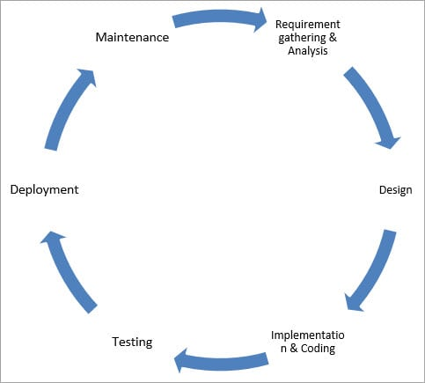

*Figure 1:* *SDLC life cycle*

#### **4.3.2 SDLC Phases**

Given below are the various phases:

* Requirement gathering and analysis
* Design
* Implementation or coding
* Testing
* Deployment
* Maintenance

##### 1) Requirement Gathering and Analysis

During this phase, all the relevant information is collected from the customer to develop a product as per their expectation. Any ambiguities must be resolved in this phase only.

Business analyst and Project Manager set up a meeting with the customer to gather all the information like what the customer wants to build, who will be the end-user, what is the purpose of the product. Before building a product a core understanding or knowledge of the product is very important.

For Example, A customer wants to have an application which involves money transactions. In this case, the requirement has to be clear like what kind of transactions will be done, how it will be done, in which currency it will be done, etc.

Once the requirement gathering is done, an analysis is done to check the feasibility of the development of a product. In case of any ambiguity, a call is set up for further discussion.

Once the requirement is clearly understood, the SRS (Software Requirement Specification) document is created. This document should be thoroughly understood by the developers and also should be reviewed by the customer for future reference.

##### 2) Design

In this phase, the requirement gathered in the SRS document is used as an input and software architecture that is used for implementing system development is derived.

##### 3) Implementation or Coding

Implementation/Coding starts once the developer gets the Design document. The Software design is translated into source code. All the components of the software are implemented in this phase.

##### 4) Testing

Testing starts once the coding is complete and the modules are released for testing. In this phase, the developed software is tested thoroughly and any defects found are assigned to developers to get them fixed.

Retesting, regression testing is done until the point at which the software is as per the customer’s expectation. Testers refer SRS document to make sure that the software is as per the customer’s standard.

##### 5) Deployment

Once the product is tested, it is deployed in the production environment or first [UAT (User Acceptance testing)](https://www.softwaretestinghelp.com/what-is-user-acceptance-testing-uat/) is done depending on the customer expectation.

In the case of UAT, a replica of the production environment is created and the customer along with the developers does the testing. If the customer finds the application as expected, then sign off is provided by the customer to go live.

##### 6) Maintenance

After the deployment of a product on the production environment, maintenance of the product i.e. if any issue comes up and needs to be fixed or any enhancement is to be done is taken care by the developers.

I have selected Agile methodology as the main roadmap of developing this system. Agile Model is a combination of the Iterative and incremental model. This model focuses more on flexibility while developing a product rather than on the requirement.

In Agile, a product is broken into small incremental builds. It is not developed as a complete product in one go. Each build increments in terms of features. The next build is built on previous functionality.

In agile iterations are termed as sprints. Each sprint lasts for2-4 weeks. At the end of each sprint, the product owner verifies the product and after his approval, it is delivered to the customer.

Customer feedback is taken for improvement and his suggestions and enhancement are worked on in the next sprint. Testing is done in each sprint to minimize the risk of any failures. The reasons which we have used Agile model are as below:

#### 4.3.3 Advantages of Agile Model

* It allows more flexibility to adapt to the changes.
* The new feature can be added easily.
* Customer satisfaction as the feedback and suggestions are taken at every stage.

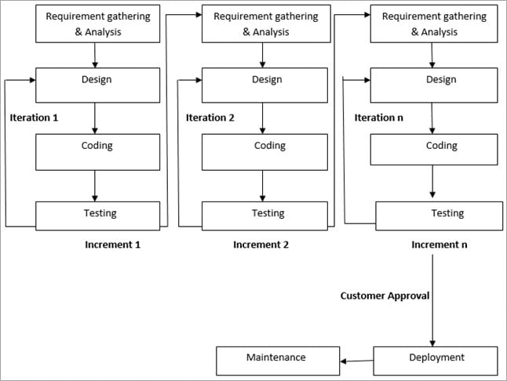

*Figure 2: Agile model*

# CHAPTER V

## PROJECT DESIGN

### 5.1. Data Flow Diagram (DFD)

A data flow diagram (DFD) is a graphical representation of the "flow" of data through an information system, modeling its process aspects. A DFD shows what kind of information will be input to and output from the system, where the data will come from and go to, and where the data will be stored.

The development of DFD’S is done in several levels. Each process in lower level diagrams can be broken down into a more detailed DFD in the next level. The Top-level diagram is often called context diagram. It consists a single process bit, which plays vital role in studying the current system. The process in the context level diagram is exploded into other process at the first level DFD. Figures 3.1 to 3.3 shows a data flow diagram about the system.

#### **DFD Level 0:**

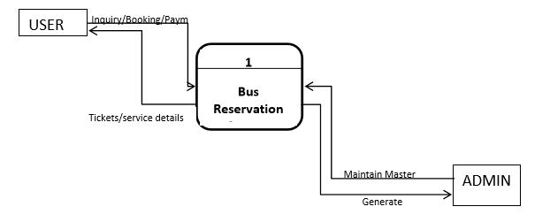

*Figure 3: Context View of Online Bus Ticket Reservation System*

#### **DFD Level 1:**

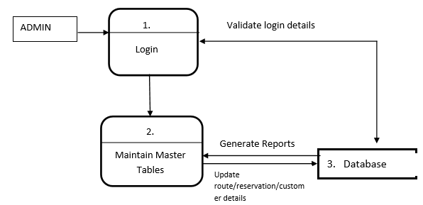

*Figure 4: User view of Online Bus Ticket Reservation System*

#### **DFD Level 2:**

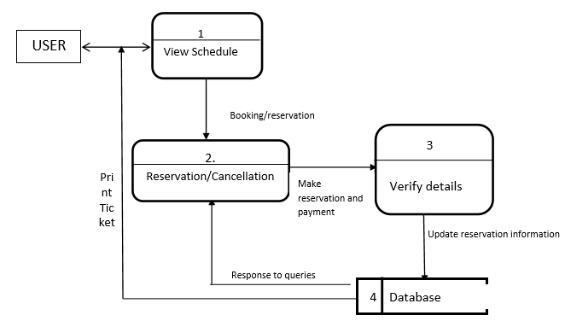

*Figure 5:* *Admin view of Online Bus Ticket Reservation System*

### 5.2. Users use case diagrams

A use case is a description of a system’s behavior as it responds to a request that originates from outside of that system (the user). In figure 3.4, a use case of the activities in a bus transport system is shown.

#### **5.2.1 Admin Use Case**

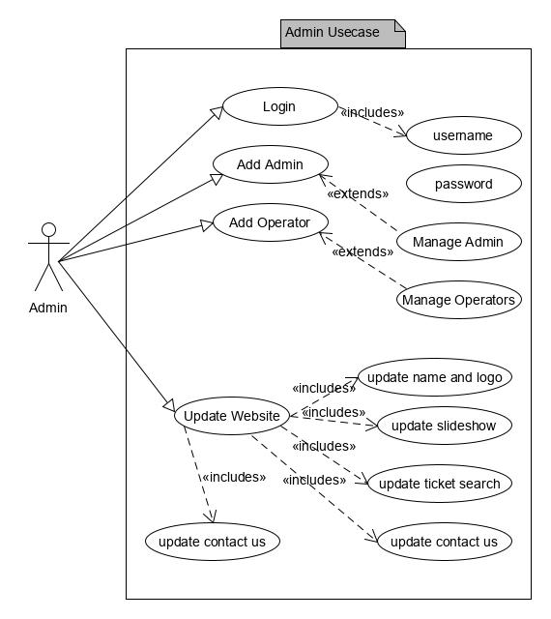

*Figure 6: Admin use case diagram*

#### **5.2.2 Operator Use Case**

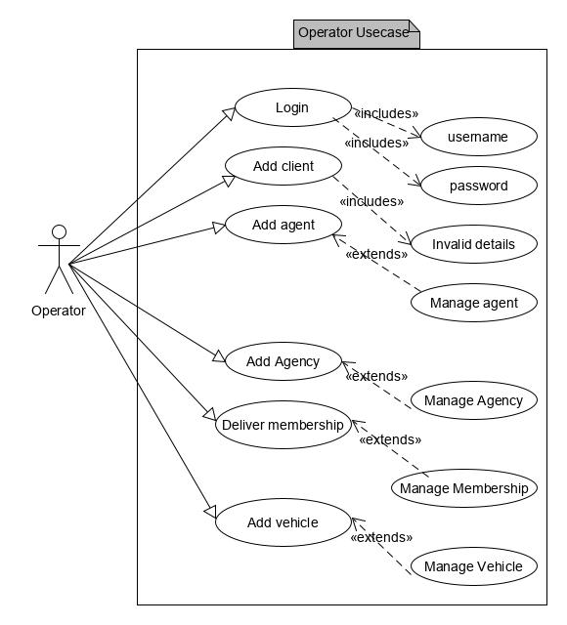

*Figure 7: Operator use case diagram*

#### **5.2.3 Client Use Case**

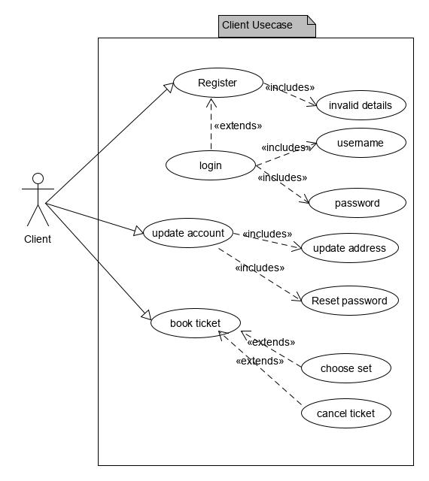

*Figure 8: Client use case diagram*

### 5.3. Entity Relationship Diagram (ERD)

* Entity relationship (ER) diagram is used in modern database software engineering to illustrate logical structure of database. It is a relational schema database modeling method used to model a system and approach. This approach commonly used in database design. The diagram created using this method is called E-R diagram.
* The E-R diagram depicts the various relationships among entities considering each object as entity. Entity is represented as diamond shape and relationship is represented as rectangle. It depicts the relationship between data objects. The E-R diagram is the relation that is used to conduct the data modeling activity.

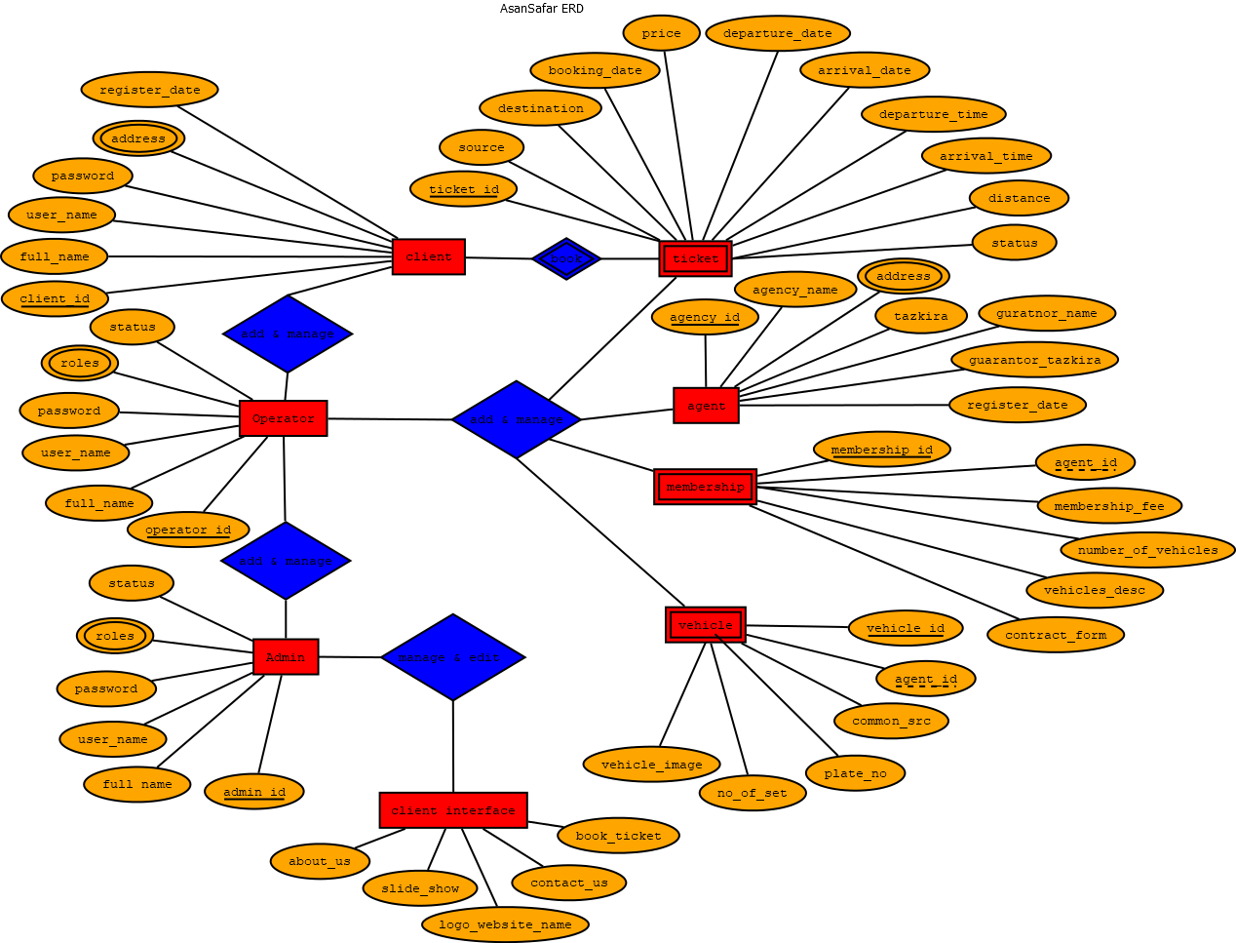

*Figure 9: Entity Relationship Diagram (ERD)*

### 5.4 List of tables

#### **Table 5.4.1: Client table**

|  |  |  |
| --- | --- | --- |
| **Column Name** | **Data type and length** | **Constraints** |
| clientId | Int(10) | Primary key, auto_increment |
| clientFullName | Nvarchar(50) | Not null |
| clientEmail | Nvarchar(50) | Not null, unique |
| clientMobile | Nvarchar(20) | Not null, unique |
| clientPermenantAddress | Nvarchar(50) | Not null |
| clientCurrentAddress | Nvarchar(50) | Not null |
| clientPassword | Nvarchar(20) | Not null |
| clientRegisterDate | Datetime | Current_time_stamp |
| clientEditDate | Datetime | Default current_time_stamp |
| clientStatus | Int(1) | Default ‘1’ |

#### **Table 5.4.2: Operator table**

|  |  |  |
| --- | --- | --- |
| **Column Name** | **Data type and length** | **Constraints** |
| operatorId | Int(10) | Primary key, auto_increment |
| operatorFullName | Nvarchar(50) | Not null |
| operatorEmail | Nvarchar(50) | Not null, unique |
| operatorMobile | Nvarchar(20) | Not null, unique |
| operatorPassword | Nvarchar(20) | Not null |
| operatorRegisterDate | Datetime | Current_time_stamp |
| operatorEditDate | Datetime | Default current_time_stamp |
| operatorStatus | Int(1) | Default ‘1’ |

#### **Table 5.4.3: Admin table**

|  |  |  |
| --- | --- | --- |
| **Column Name** | **Data type and length** | **Constraints** |
| adminId | Int(10) | Primary key, auto_increment |
| adminFullName | Nvarchar(50) | Not null |
| adminEmail | Nvarchar(50) | Not null, unique |
| adminMobile | Nvarchar(20) | Not null, unique |
| adminPassword | Nvarchar(20) | Not null |
| adminRegisterDate | Datetime | Current_time_stamp |
| adminEditDate | Datetime | Default current_time_stamp |
| adminStatus | Int(1) | Default ‘1’ |

#### **Table 5.4.4: Client Feedback table**

|  |  |  |
| --- | --- | --- |
| **Column Name** | **Data type and length** | **Constraints** |
| id | Int(10) | Primary key, auto_increment |
| question | Nvarchar(200) | Not null |
| optionA | Nvarchar(50) | Not null |
| optionB | Nvarchar(20) | Not null |
| optionC | Nvarchar(20) | Not null |
| optionD | Nvarchar(20) | Not null |

#### **Table 5.4.5: Contact us table**

|  |  |  |
| --- | --- | --- |
| **Column Name** | **Data type and length** | **Constraints** |
| Address | Nvarchar(50) | Not null |
| Email | Nvarchar(50) | Not null, unique |
| contactNoOne | Nvarchar(20) | Not null, unique |
| contactNoTwo | Nvarchar(20) | Not null, unique |
| websiteShortDescription | Nvarchar(200) | Not null |
| websiteDomainName | Nvarchar(50) | Not null |

#### **Table 5.4.6: Feedback collection table**

|  |  |  |
| --- | --- | --- |
| **Column Name** | **Data type and length** | **Constraints** |
| feedbackId | Int(10) | Primary key, auto_increment |
| clientId | Int(10) | Foreign key |
| question1 | Nvarchar(100) | Not null |
| answer1 | Nvarchar(20) | Not null |
| question2 | Nvarchar(100) | Not null |
| qnswer2 | Nvarchar(20) | Not null |
| question3 | Nvarchar(100) | Not null |
| qnswer3 | Nvarchar(20) | Not null |
| question4 | Nvarchar(100) | Not null |
| qnswer4 | Nvarchar(20) | Not null |
| Suggestion | Nvarchar(200) | Not null |
| customerFullName | Nvarchar(50) | Not null |
| customerAddress | Nvarchar(100) | Not null |
| customerMobileNumber | Nvarchar(20) | Not null |
| customerEmail | Nvarchar(50) | Not null |

#### **Table 5.4.7: Logging table**

|  |  |  |
| --- | --- | --- |
| **Column Name** | **Data type and length** | **Constraints** |
| logId | Int(10) | Primary key, auto_increment |
| username | Nvarchar(50) | Not null |
| userType | Nvarchar(20) | Not null |
| activityType | Nvarchar(20) | Not null |
| logMsg | Nvarchar(200) | Not null |
| logDateTime | Datetime | Default current_time_stamp |

#### **Table 5.4.8: Membership table**

|  |  |  |
| --- | --- | --- |
| **Column Name** | **Data type and length** | **Constraints** |
| membershipId | Int(10) | Primary key, auto_increment |
| agencyId | Int(10) | Foreign key |
| agentFullName | Nvarchar(50) | Not null |
| membershipDate | Datetime | Default current_time_stamp |
| agencyAddress | Nvarchar(50) | Not null |
| totalNumberOfVehicles | Int(2) | Not null |
| vehiclesDescription | Nvarchar(200) | Not null |
| membershipFee | Decimal (10) | Not null |
| paidAmount | Decimal (10) | Not null |
| remainingAmount | Decimal (10) | Not null |
| contractFileName | Nvarchar(200) | Not null |

#### **Table 5.4.9: Agency (Vehicle Owner) table**

|  |  |  |
| --- | --- | --- |
| **Column Name** | **Data type and length** | **Constraints** |
| ownerId | Int(10) | Primary key, auto_increment |
| ownerFullName | Nvarchar (50) | Not null |
| ownerEmail | Nvarchar (50) | Not null, unique |
| ownerMobile | Nvarchar (50) | Not null, unique |
| ownerRegisterDate | Datetime | Default current_time_stamp |
| ownerTazkira | Nvarchar (100) | Not null |
| guarantorDetails | Nvarchar (100) | Not null |
| guarantorTazkira | Nvarchar(100) | Not null |

#### **Table 5.4.10: Vehicle table**

|  |  |  |
| --- | --- | --- |
| **Column Name** | **Data type and length** | **Constraints** |
| vehicleId | Int(10) | Primary key, auto_increment |
| vehiclePlateNo | Nvarchar (10) | Not null, unique |
| vehicleType | Nvarchar (20) | Not null |
| numberOfSets | Int(20) | Not null |
| commonSourcePlace | Nvarchar (40) | Not null |
| commonDestinationPlace | Nvarchar (40) | Not null |
| vehicleImage | Nvarchar (100) | Not null |
| travelAgencyDetails | Nvarchar(100) | Not null |
| driverDetails | Nvarchar (100) | Not null |
| cleanerDetails | Nvarchar (100) | Not null |
| ownerId | Int(10) | Foreign Key |

#### **Table 5.4.11: Ticket table**

|  |  |  |
| --- | --- | --- |
| **Column Name** | **Data type and length** | **Constraints** |
| ticketId | Int(10) | Primary key, auto_increment |
| sourcePlace | Nvarchar (40) | Not null |
| destinationPlace | Nvarchar (40) | Not null |
| distance | Int(5) | Not null |
| departureDate | Datetime | Datetime |
| arrivalDate | Datetime | Datetime |
| dapartureTime | Nvarchar (20) | Not null |
| arrivalTime | Nvarchar(100) | Not null |
| vehicleId | Int (10) | Foreign key |
| Price | Decimal (5) | Not null |
| setNo | Int (20) | Not null |
| Discount | int (20) | Not nul |
| Status | Int(1) | Default ‘1’ |
| bookingDate | Datetime | Datetime |
| clientId | Int (10) | Foreign key |
| vehicleType | Nvarchar (20) | Not null |

#### **Table 5.4.12: Website about table**

|  |  |  |
| --- | --- | --- |
| **Column Name** | **Data type and length** | **Constraints** |
| About | Nvarchar(2000) | Not null |

#### **Table 5.4.13: Website name and logo table**

|  |  |  |
| --- | --- | --- |
| **Column Name** | **Data type and length** | **Constraints** |
| websiteName | Nvarchar (100) | Not null |
| websiteLogo | Nvarchar (100) | Not null |

#### **Table 5.4.13: Website slideshow table**

|  |  |  |
| --- | --- | --- |
| **Column Name** | **Data type and length** | **Constraints** |
| Id | Int (20) | Not null |
| slideImage | Nvarchar (100) | Not null |
| slideTitle | Nvarchar (100) | Not null |
| slideDescription | Nvarchar (100) | Not null |

### 5.5 Project main modules and features

This project has the following modules, to manage all the requirements of the transporter management system.  
  
**1. Client Management   
2. Admin Management   
3. Operator Management   
4. Agency Management  
5. Membership Management   
6. Vehicle management  
7. Ticket Management**

**8. Clients Feedback Management**

**9. Client interface editor interface**

**10. Logging management   
11. Reports Managements**

Transport Management System includes Load Planning, Vehicle Scheduling, Route optimization and Driver Management for easily manages all Transport Needs. transport management system project, Ask Latest information, Abstract, Report, Presentation (pdf,doc,ppt),transport management system project.  Are you looking for transport management system? Get details of transport management system. We collected most searched pages list related with transport management. This file is used for creating transportation and travelling management project Chennai Corporation’s key projects to promote non-motorized transport a cycle-sharing system, dedicated cycle tracks and a parking management system will be implemented under a public private partnership arrangement. Transport Management A Self-Learning Guide for Local Transport Managers of Public Health Services OCTOBER 2010 This publication was produced for review by the U.S. A transportation management system (TMS) is a subset of supply chain management concerning transportation operations and may be part of an enterprise. Transportation System Management Project Implementation Program Area: The Transportation System Management Project Implementation program area focuses. Project Report of Transport Management System document sample transport management projects which focus specifically on each of the four main transport (Intelligent Transport Systems) deployment in four pilot cities; and a Content teller is a strong content management system written in the PHP scripting language designed for sites of all sizes and types.

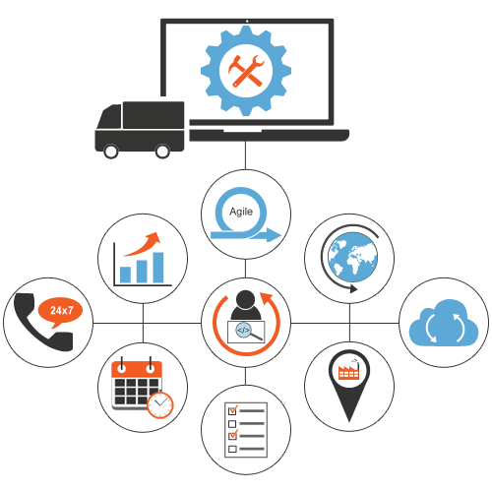

*Figure 10: AsanSafar modules and features*

#### **5.5.1 Admin Module**

In Admin Module, is like the master key as it has access to all the data and also access and make changes in any of the three modules. Hence providing total authority and independence to admin. The database of admin in back end has attributes like admin name, admin email and contact number.

The admin user can have overall privileges of the system. He/she can update the website i.e. update the website name and logo, slideshows, about us details, feedback and contact us details. Admin can manage operators and other admins as well.

#### **5.5.2 Operator Module**

The operator can be registered by admin. The operator can manage clients and tickets. He/she can register vehicles, agency and grant membership to agencies. The operators can add and manage tickets.

#### **5.5.3 User Module**

This is the most important module of whole system as this the module which going to be used by several user and depending on this Quality, compatibility, precision of the system is going to be depended. As being the User Interface and mediator between user and system it has to be at its best.

#### **5.5.4 Vehicle Module**

The executive comprises the vehicle module. This module keeps up the points of interest of vehicles and taxis accessible for transportation. For every vehicle subtle element, for example, plate number, vehicle type, capacity, availability will be put away. A manager can deal with the vehicle data.

#### **5.5.5 Route Module**

The overseer comprises the course module. This module keeps up the subtle elements of all courses accessible for transportation. For each course subtle elements, for example, course number, stopping points, pickup time for each stop focuses will be put away. Manager can deal with the course data

#### **5.5.6 Report Module**

The report can be exported in PDF, EXCELL format and can be also directly printed.

### 5.6 Wireframes and pages

In logical design part, I have created the complete website wireframes and structure which can be used as roadmap for developing the system. This wireframe is used step by step while developing the system.

#### **Client Interface – Page 1**

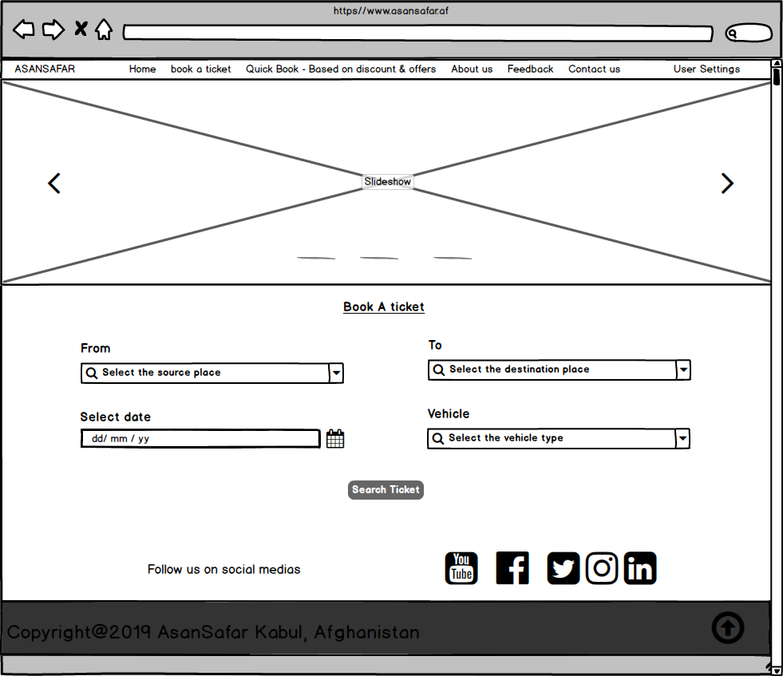

*Figure 11:* *AsanSafar home page - 1*

#### **Client Interface – Page 2**

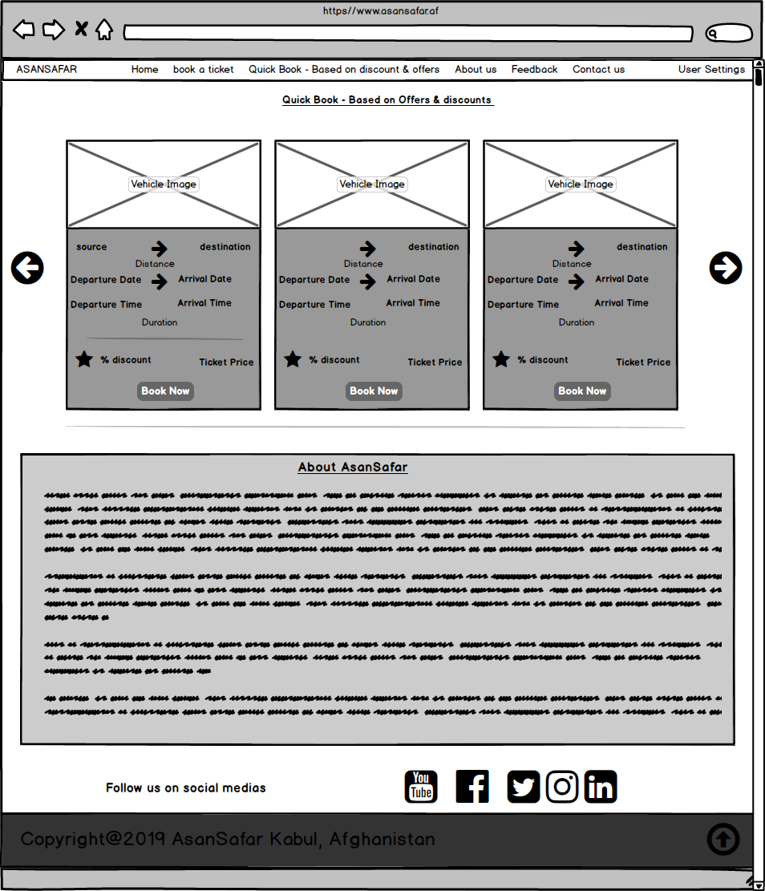

*Figure 12: AsanSafar ticket search page - 2*

#### **Client Interface – Page 3**

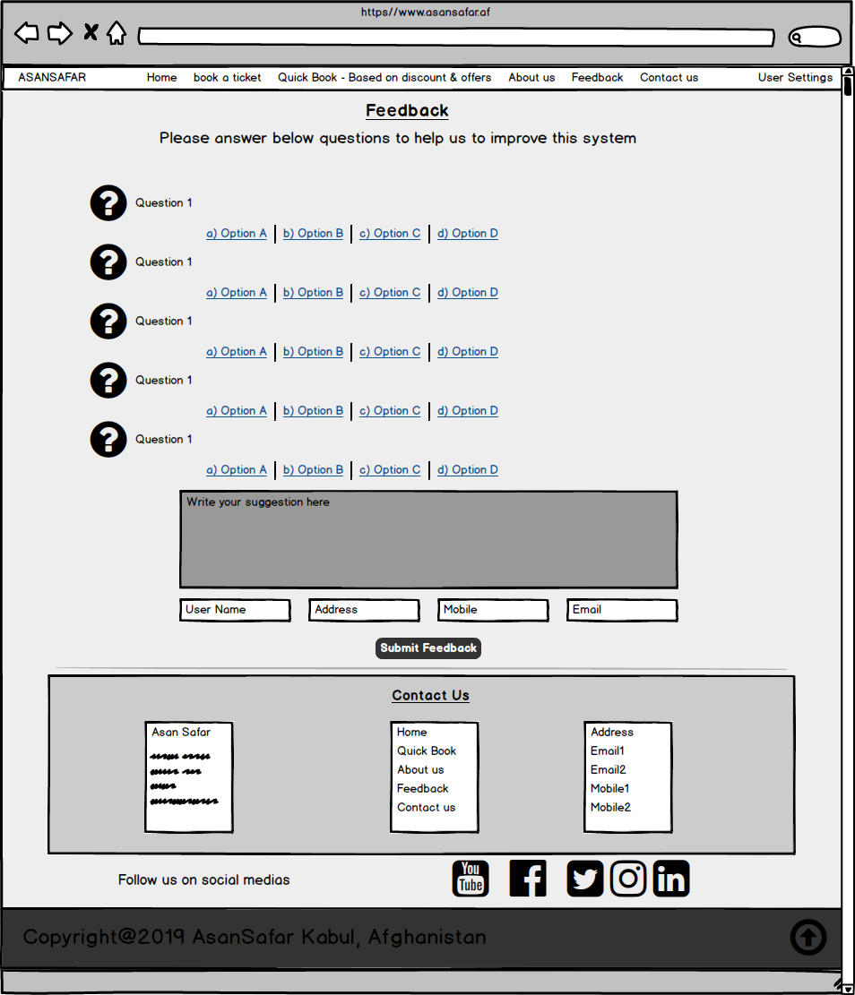

*Figure 13: AsanSafar feedback and contact us*

# CHAPTER VI

## PROJECT IMPLEMENTAION & REQUIREMENTS

### 6.1. Software Requirements

Operating System: Windows/ Linux and Mac

Web Technology: HTML, CSS, JavaScript, jQuery, Bootstrap, PHP

Web Server: Tomcat

Database: My SQL

Java Version: J2SDK1.5

### 6.2. Hardware Requirement

Speed – 1.1 GHz

RAM: minimum 2GB

Hard Disk – 10 GB

### 6.3. Advantages

* Easy access to the data
* The new system is more user-friendly, reliable and flexible.
* Data alteration is easy.
* Maintenance of the project is easy.
* Reduced manual work.
* Timely Report generation.

## 

# CONCLUSION

BUS TRANSPORT MANAGEMENT SYSTEM is a web-based application. Which has high integrity to change the current problems and system failure. It’s going to be the need and optimum option for comfortable travel experience in future. Also, the same system with some basic and minute changes in programming and interface can be implemented for metros and railways also. From our project experience we have experienced that computerized system id more helpful rather than standing in queue for bookings. It helped us to get in depth knowledge about how system is planned, organized and managed. It’s not everyone’s cup of tea to manage such a huge transportation system so, by implementing BUS TRANSPORT MANAGEMENT SYSTEM things are going to get much better.

It can be observed that computer applications are very important in every field of human endeavor. Here all the information about customer that made reservation can be gotten just by clicking a button with this new system, some of the difficulties encountered with the manual system are overcome. It will also reduce the workload of the staff, reduce the time used for making reservation at the bus terminal and also increase efficiency. The application also has the ability to update records in various files automatically thereby relieving the company’s staff the stress of working from file security of data.

This project, as a whole, will give a new way in bus reservations and ticketing processes. The automation and management of seats and reservations will be done online. However, this project does not limit the walk-in passengers that is passengers who visit the company’s counter because it also caters for them. This also lessens the use of papers like in the traditional way of ticketing.

# REFERENCES

## Books & Research papers

1. Kevin O. C., (2012): Web-Based Bus Reservation and Ticketing System: College of Computer Studies, Ateneo de Naga University, Naga City, Philippines - February 26, 2012
2. Laweb,(2010): "Central Reservation System | Online Hotel Marketing Services, Hong Kong and Philippines Hotel, Spa and Restaurant Software". Iaweb.net. 2010. Retrieved - 2012-11-08
3. Rainer, R., Roberts, T., Gibson, M., Fields, K., and (1998): Factors that Impact Implementing a System Development Methodology. IEEE Transactions on Software. vol. 24.
4. Wee K. L. (2007): Bus Reservation System: Faculty of Information and Communications Technology,Universiti teknikal Malaysia Melaka

## Websites

1. <https://en.wikipedia.org/wiki/Public_transport>
2. <http://www.bakhtarnews.com.af/eng/social/item/40116-kabul-city-to-witness-bus-transportation-system.html>
3. <https://www.cdc.gov/policy/hst/hi5/publictransportation/index.html>
4. <https://www.sciencedirect.com/science/article/pii/S0191261515000454>
5. <https://www.researchgate.net/publication/258047988_Intelligent_Public_Transportation_Systems_A_Review_of_Architectures_and_Enabling_Technologies>
6. <https://www.plslogistics.com/blog/the-importance-of-transportation-management/>
7. <https://www.nationalexpresstransit.com/blog/importance-of-transportation-management/>
8. <https://cerasis.com/benefits-of-tms/>
9. <https://supplychainbeyond.com/10-reasons-to-consider-a-transportation-management-system-tms/>
10. <https://www.oracle.com/applications/supply-chain-management/what-is-transportation-management-system.html>
11. <https://www.kuebix.com/why-is-transportation-management-important/>
12. <https://medium.com/@hughesdavid/the-critical-role-of-transportation-management-in-logistic-business-821ac46f2c2a>
13. <https://www.datexcorp.com/top-7-benefits-implementing-transportation-management-system/>
14. <https://www.taxicaller.com/en/features/dispatch-system?gclid=EAIaIQobChMIm8jEr8ry5wIVFs93Ch0R4g52EAMYASAAEgLFd_D_BwE>